Prorject Team

WELTEC

Project Proposal



|  |  |  |  |
| --- | --- | --- | --- |
| Project Proposal | Reference  WelTec | Subject  Project Proposal | Date  25-Apr-2016 |
| Customer  WELTEC | Engagement  <Name Engagement> | Contractno  <Number> |
| Practice  HK | Sector  DBA | Version |
| Author  Hardik Kansara | Signature | Status |

Document history

|  |  |  |  |  |
| --- | --- | --- | --- | --- |
| Version | Date | Author | Changes | Valid from |
| 1.0 | 19-Jul-2016 | Changming Wu | Edit | 19-Jul-2016 |
| 1.1 | 19-Jul-2016 | Changming Wu | Edit | 19-Jul-2016 |
| 1.2 | 19-Jul-2016 | Hardik Kansara, Patrick Cura | Edit | 19-Jul-2016 |
| 1.3 | 19-Jul-2016 | Kwinno Pineda, Patrick Cura | Edit | 19-Jul-2016 |
| 1.4 | 31-Jul-2016 | Kwinno Pineda, Patrick Cura | Edit | 31-Jul-2016 |
| 1.5 | 01-Aug-2016 | Changming Wu | Edit | 01-Aug-2016 |

Table of Contents

1 Executive Summary 3

2 Opportunity Context 4

3 Project Requirements 5

4 Project Analysis 6

5 System Outline 7

6 Approach 9

7 Organization of the Project 11

8 Management 13

9 Plans and Procedures 14

10 Staff 15

11 Deliverables 15

12 Resumes (CVs) 16

13 Relevant Background Information 17

14 Resources 17

15 Customer Acceptance 17

16 Appendices 18

# Executive Summary

Database implementation is one of the biggest challenges for an organization and a database administrator.

One of the reasons for this is that at the beginning of the implementation, there are already some critical installation options that need to be addressed. These installation options include drive and database physical structure selection which are not easy to change after the database is hosted.

There are also some parameters like authentication and network communication port configuration which need to be considered. These are essential to check in the database production environment to overcome the security loopholes.

Other things to consider are memory, CPU, database recovery model and compatibility level parameters which all affect database performance if they are not tuned during the initial phases of database implementation.

Given all the said database implementation considerations, it will be difficult for a database administrator to check and create an inventory of all the database parameters which are used and configured. Maintaining the database in accordance to best practice will surely become a challenge. This will especially become painful for a new database administrator who needs to figure out the implementation parameters of all previous SQL Server instances and databases.

With the said challenges, the group aims to produce a database evaluator that will diagnose and check the basic implementation parameters of SQL Server Instances and Databases. The database evaluator will target all versions of SQL Server starting with SQL Server 2008 and SQL Server 2012. Older versions of SQL server will not be supported.

A database administrator can make use of the developed tool to generate reports about the configured database parameters. This tool will become very useful in case you have multiple SQL Server instances installed. A report will be generated for each instance and these reports will show details about mismatched parameters. From these reports, a database administrator can take necessary actions to improve their database implementation. In addition, the tool can also be used to audit SQL Server instances and databases on regular time intervals for database maintenance purposes.

The project will run under a Software Engineering methodology, which will produce a high quality product and has no associated costs or risks in the implementation. The project also has several management controls built in, this is to minimise the risk areas and improve the quality of the product. There are the standard advisor meetings, timecard, diaries and audits. Also, change request controls are used to control the processes used to develop and change the project.

The final products of the project are as follows: a) the client application that will produce a dump file of the client’s database, b) the product website where a customer can download the client application and upload the database dump files, and c) the database evaluator tool that will generate reports from the dump files uploaded by customers. The dump files contain information about database of the client. It is planned that these dump files will be encoded for security purposes. The client application is free to download from the product website and profit will be generated instead when customers choose to avail of the database evaluation services.

# Opportunity Context

The team need to do a project as part of their degree programme where team needs to find a suitable project client, to develop a solution to meet the client’s requirements to fulfil their project.

However the project team want to attract clients who has implemented SQL server in their infrastructure and want to know the implementation risk and verify the configuration of databases and SQL Server. The biggest opportunity with this project are first client can simply see what are missing parameters in exiting implementation and second if they have large number of SQL Server instances to be audited then it’s very easy by this tool.

This tool creates an opportunity for both customer and project team. Customer will get the benefit of audit report and tune their database parameters before it’s late. Sometimes it will costly for small business to hire professional or contractor to evaluate their database system.

So this tool is for business or customer who don’t want to hire full time database administrator to diagnose their database system. It will also useful as audit tool without worry of your actual data in database.

The dump file only contains basic parameter values which will be verify by our project team so customer data is safe because project team don’t have direct access of customer database.

# Project Requirements

The project team’s requirements are 400 hours of work each of the project member. The project will be due on the 4nd of November 2016.

From Project team perspective, team will develop Website which help customer to download client application.

A client application is light weight and small tool which will be executed on customer database system and gather the parameters configured values and captured in encrypted file.

Same website will help customer to upload the file after successfully login into their account.

Parameters in encrypted file will be diagnose with another application called database simulator. Database simulator will check all the parameter against the best practice values and generate the final report.

Final report have all information about what parameters are not configured and what will be the parameter values as per suggested best practice.

Customer can download final report from website.

Following areas of database from where parameters values will be collected by client application.

* SQL Server Instance

1. Installation

2. Configuration

3. Security

* SQL Server Database

1. Implementation of Database (physical structure)

2. Database Configuration Options

3. Maintenance

4. Security

# Project Analysis

The team is composed of a Database Specialist, a Web Developer, a Programmer and a certified Project Manager.

Given that our target market are users of Microsoft SQL Servers, we have a Database Specialist who is experienced in handling and administering Microsoft SQL Servers. With his skills, we are confident that a Database Evaluator tool that is up to standards will be produced.

Given that the target RDBMS is a Microsoft Product, the Database Evaluator should be built using a Microsoft product as well. In this case, the team’s Programmer has a choice between Visual Basic or C# to create the Windows Form Application. The Programmer has a background in Java so the logical choice between VB and C# is C# as it more closely identical to Java. Since there is a fixed deadline that needs to be met, every moment is important so trying to learn a new language with unfamiliar syntax should be avoided. For the IDE, Visual Studio will be used as it already has some drag and drop tools to make the development of the GUI of the desktop application easier.

Besides the actual Database Evaluation tool, a product website is also needed. The product website is where the tool will be downloaded by the users. There are a lot of available technologies that can be used for web development but because time is of the essence, the chosen ones are PHP, WordPress and MySQL. The team’s Web Developer already has experience in creating websites using the said technologies and this will allow us to develop the website quickly along with the tool. Also, WordPress, being a CMS tool, has a lot of Plugins and Themes that just needs to be imported to use. These plugins will make designing the website much easier. Furthermore, finding resources and references for the said technologies will be easier given that many websites are built from them.

To keep track of the code and documentation updates and changes, a source code and document management application needs to be used. There are a lot of available applications but GitHub will be used for our purposes. The reason is that it is quite easy to use even for first time users given that there is GitHub Desktop for easy upload.

The DSDM Atern development framework will be used instead of the OpenUP methodology. This is because the time and cost for DSDM Atern are fixed which leaves us to worry about scope only. Another reason why we chose DSDM Atern is because it has a large community worldwide with different companies using this agile methodology. Furthermore, DSDM Atern can be used for large and small projects depending on the needs of the project. Using DSDM Atern, risks will be minimized as the project progresses because of its iterative and incremental approach. In our case, the team project owner will be the same as the user in this project. User involvement is a vital requirement. The user is the one who will be consulted for changes and additional requirements which are discussed during the kick-off meetings.

# System Outline

The final products of the project are as follows:

* A client application that will produce a dump file of the client’s database information.
* The client application is a light weight tool which will need to be installed on the customer system. It will connect to the SQL server instance and then execute.
* It will generate the encrypted dump file which contains all the current information of all the predefine areas of SQL server instance and database.
* Evaluator either run to check only SQL Server instance configuration or you can execute on instance with single database.
* You cannot execute the evaluator on multiple database at a same time.
* b) The website from where a customer can download the database evaluator and upload the generated dump files.
* A website is used to download database evaluator tool and upload the dump file.
* A website page also help customer to know the tool installation procedures along with term and conditions agreements between customer and us.
* The database evaluator tool that will generate reports from the dump files uploaded by customers.
* The encrypted dump file contains the customer database parameters values only. It is planned that these dump files will be encoded for security purposes.
* The client application is free to download from the product website and profit will be generated when customers choose to avail of the database evaluation services.

See Data Flow Diagram at Page 9

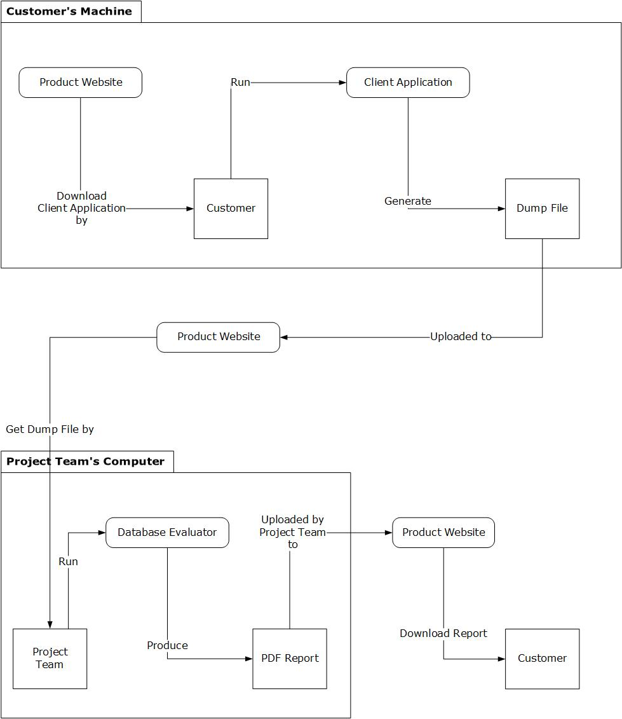

# Approach

Dynamic System Development Model Atern (DSDM Atern), which is an agile development framework, will be used to produce the desired product of this project. DSDM Atern is one of the agile frameworks that companies use due to its features of fixed time and cost. Scope will be the only factor that will change mostly in this project. The Project in a Box has DSDM Atern templates. These will greatly help us in delivering documents and keep us on the right track throughout the project.

This project will use the 7 phases of DSDM Atern which are as follows:

1. Pre-project

2. Feasibility

3. Foundation

4. Exploration

5. Engineering

6. Deployment

7. Post-project

The phases of the DSDM Atern will be used as the guide in setting the dates, and distributing and prioritizing tasks. DSDM follows a reverse triangle planning. The project requirements must be extensively and carefully planned at the start before proceeding to the next phases. Delivering the deliverables on time without sacrificing the quality is what makes DSDM hard to use but worth it at the end. Project management techniques will be used to deliver the solution on time. These techniques will act as the blueprint of the project and will be strictly followed by every member in the project.

Core techniques in DSDM Atern are as follows:

1. Time Boxing

2. MoSCoW Prioritisation

3. Facilitation Workshop

The MoSCoW term above stands for the following:

M – Must Have

S – Should Have

C – Could Have

W – Won’t Have this time

“Must Have” are the core tasks and are prioritized for the project. Not all tasks should be assigned under “Must Have” especially if it is not important or if it will not affect the project. Most of the remaining items can be moved to “Should Have” or “Could Have”. “Won’t have this time” will be the tasks that could done once the other important tasks are delivered.

Time Boxing will be used as the task planner of the project. Every task of the project will be done using time box approach. Each member will be assigned a task that must be done for the day and a progress report will be collected by the end of each week regarding the team’s accomplishments.

Facilitation Workshops will also be used. It is composed of meetings where progress is checked and tasks are distributed. This will be the time to talk about any suggestions about the project, risks that may arise, and confusions about each task.

# Organization of the Project

Below is a breakdown of the people involved:

* Project Manager, Test Manager
  + Changming Wu
* Database Specialist, Tester
  + Hardik Kansara
* Web Developer, Tester
  + Kwinno Pineda
* C# Developer, Tester
  + - * Patrick Cura

Also, here are the main tasks that need to be done:

1. Create the Project Specification and Requirements
2. Create the Test Plan
3. Test the Applications
4. Create the Customer Application
5. Create the Project Website Application
6. Create the Database Evaluator
7. Create the Database Evaluation Guidelines and the related Query Scripts
8. Handle the Project Management Aspects for the team

From the details given above, here is a RACI chart that shows which people will be assigned to which tasks:

|  |  |  |  |  |
| --- | --- | --- | --- | --- |
| Tasks | Changming Wu | Hardik Kansara | Kwino Pineda | Patrick Cura |
| 1. Create the Project Specification and Requirements | C I | R A | C I | C I |
| 1. Create the Test Plan | R A | C I | C I | C I |
| 1. Test the Applications | A C | R | R | R |
| 1. Create the Customer Application | I | C | I | R A |
| 1. Create the Project Website Application | I | C I | R A | C I |
| 1. Create the Database Evaluator | I | C | I | R A |
| 1. Create the Database Evaluation Guidelines and the related Query Scripts | I | R A | I | C I |
| 1. Handle the Project Management Aspects for the team | R A | C I | C I | C I |

For Task 1, the Database Specialist will handle the creation of the project specification and requirements because it is his domain of expertise. He will consult and inform of the team of the scope so as to get a consensus if the team can do it as per their current skills.

For Task 2, the Test Manager will handle the creation of the Test Plan document and will consult and inform the developers and specialist regarding the validity of the test that will be created.

For Task 3, everyone in the team will do testing. Each one will test an application that they did not create to avoid biased testing. The test manager should ensure that everyone will contribute to the testing.

For Task 4 and 6, the C# developer will mainly be in charge of creating the customer application (the one to be distributed to customers) and the Database Evaluator. Because database knowledge is needed in getting the needed information from a customer’s computer, the Database Specialist needs to be consulted and asked for help. The other members will be informed of the software development progress.

For Task 5, the Web Developer will be in charge of creating the website that the customers will be using. He will consult the Database Specialist and C# developer as there might be a chance that their applications will interact in the future. All team members must also be informed of the website development progress.

For Task 7, the Database Specialist will handle the creation of the Database Evaluation Guidelines and the Database Queries associated with it. This is the heart of the project and the specialist will have to apply his expertise for this. The query scripts will be provided to the C# Developer who will generate the database evaluation report.

For Task 8, the PM would handle the project management aspects for the team and would constantly consult the team if they have issues and needs.

# Management

* Collocation

Project team should work in the Lab B105 every Monday to Wednesday at Weltec. The rest time they should work in their home or private space to follow the form which includes the tasks and schedule that they have created at the beginning at the week.

* Weekly meetings

In order to track the project management, the development team will use 0.5 hour to have weekly meeting on every Tuesday 11 am – 11:30 am.

In weekly meeting, the development team will summarize and analyze the weekly project status, reflect and discuss issues which cannot be solved, and adjust the project tasks for next week plan.

* Advisor Meeting

The development team will use 0.5 hour to have weekly meeting with project.

The project advisor will inspect the completed work on weekly schedule of the development team and give the corresponding feedbacks and suggestions.

* Meeting Agenda

Before each meeting, project should send the meeting agenda to project advisor and team members. The meeting agenda should include the following:

(1) Familiarize participants with the topics to be discussed and issues to be raised; (2) Indicate what prior knowledge would be expected from the participants;

(3) Indicate what outcome the participants may expect from the meeting

* Meeting Minute

Each meeting will to be recorded including clearly reflected in each project record, party views the current state of the project and decision-making. Project manager should make the meeting minute after each meeting and send an email to project advisor and project team members including meeting minute and prior meeting agenda.

* Daily administration

Daily administration is for developers to record daily work content, time spent and the problems encountered in the course of their work, ideas and solutions to problems.

* Management tool

This project will use Github to manage materials in progress, and the deliverables. It is not only can create a repository to make sure everyone has good access to the work product but also it can backup appropriately and write comments for each changed.

# Plans and Procedures

* Tasks
* Here is a breakdown of the project plan based on the phases of the Spiral Model:

1. Identification
   * Tools
   * Software
   * Basic Requirements
2. Design
   * UI Design for Web
   * UI Design for Database Evaluator
3. Construct and Build

* Building of the Web Application
* Building of the Database Evaluator

1. Evaluation and Risk Analysis
   * Create Test Plan
   * Execute Test Plan
   * Create Risk Plan

* See Project Plan
* See Change Control Form

# Staff

The project team of this project as follows:

* Changming Wu: Project Manager, Test Manager
* Hardik Kansara: Database Specialist, Tester
* Kwinno Pineda: Web Developer, Tester
* Patrick Cura: C# Developer, Tester

They will spend 450 hours of work each on this project.

Steve McKinlay as the project advisors will inspect the completed work on weekly schedule of the development team and give the corresponding feedbacks and suggestions during the weekly advisor meeting.

We don’t have the particular client.

# Deliverables

* Project milestones and their estimated completion dates are as follows:

|  |  |  |
| --- | --- | --- |
| Milestone | | Due Date |
| Project Proposal | 22/07/2016 | |
| Project Plan/Gantt Chart | 22/07/2016 | |
| Analysis and Design Documents | 05/08/2016 | |
| Web Application Development | 06/09/2016 | |
| Website Development | 06/09/2016 | |
| Database Evaluator Development | 30/09/2016 | |
| Integration Testing | 07/10/2016 | |
| Project Presentation | To be announced | |

* Project deliverables and their estimated completion dates are as follows:

|  |  |
| --- | --- |
| Deliverable | Due Date |
| Project Proposal | 22/07/2016 |
| Project Plan/Gantt Chart | 22/07/2016 |
| Scope of Project | 29/07/2016 |
| Requirements Analysis | 05/08/2016 |
| Analysis and Design Documents | 05/08/2016 |
| Methodology and Techniques | 05/08/2016 |
| Integration Test Plan | 09/08/2016 |
| Test Case for Integration Test | 12/08/2016 |
| Test Results/Record for Integration Test | 09/09/2016 |
| System Test Plan | 20/09/2016 |
| Test Case for System Test | 23/09/2016 |
| Test Results/Record for System Test | 07/10/2016 |

# Resumes (CVs)

* See Changming Wu CV.pdf
* See Hardik Kansara CV.pdf
* See Kwinno Pineda CV.pdf
* See Patrick Cura CV.pdf

# Relevant Background Information

This project is about using Microsoft Visual Studio and SQL Server Express to develop Database simulator. Customers can download the simulator from a website, execute simulator against client system, and upload the file to the website so it will be diagnosed later.

* See Client Brief Document

# Resources

Kwinno Pineda as the Web Developer will use the following material:

* Eclipse Php editor and Notepad ++
* XAMPP
* Wordpress
* MySQL Database

Patrick Cura as the Software Developer for the Client Application and Database Evaluator will use the following material:

* Microsoft Visual Studio 2015 Enterprise Edition
* Install Shield Limited Edition for Visual Studio
* Microsoft .NET Framework 4.5.2
* SQL Server Express
* SQL Server Management Studio

All of the materials mentioned are available over the internet and will be downloaded by the developer in need of them.

# Customer Acceptance

* See Team Contact

# Appendices

* Project Plan
* Change Control form
* Client Brief Document
* Team Contact